**Video games sales Analyzing**

The gaming industry has undergone a substantial evolution since the 1970s and has moved from a fringe activity into the mainstream, Games entered the home formally with the release of an early gaming console called the Magnavox Odyssey he market lost momentum in 1977 and was rejuvenated in 1978 by another successful game called Space invaders .

In the late 1970s, personal computer gaming also took off and the development of computing led to a simultaneous advancement in gaming technology as well .

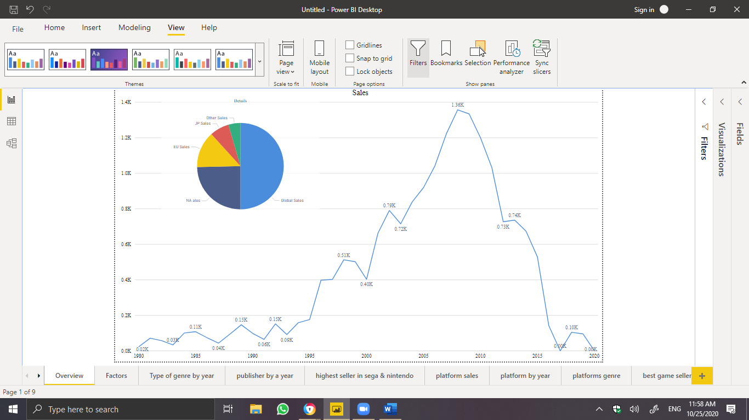

as you see here in the figure above in 2008 has the highest Sales with **1.3K** sales, then it decreased specially in 2016 with **141.40 $** sales, and 2017 with **0K** sales , and it increased back in 2018 and 2019 with **0.10K** .

Also the figure above shows the details of the sales and the highest sales is a Global sales with **50.01%** .

We trying to figure out what is the reason for that decreasing on the sales .

By doing some analysis we find out that, **the genre of game and the publisher** could affects the sales .

* **Genre and publisher Review :**

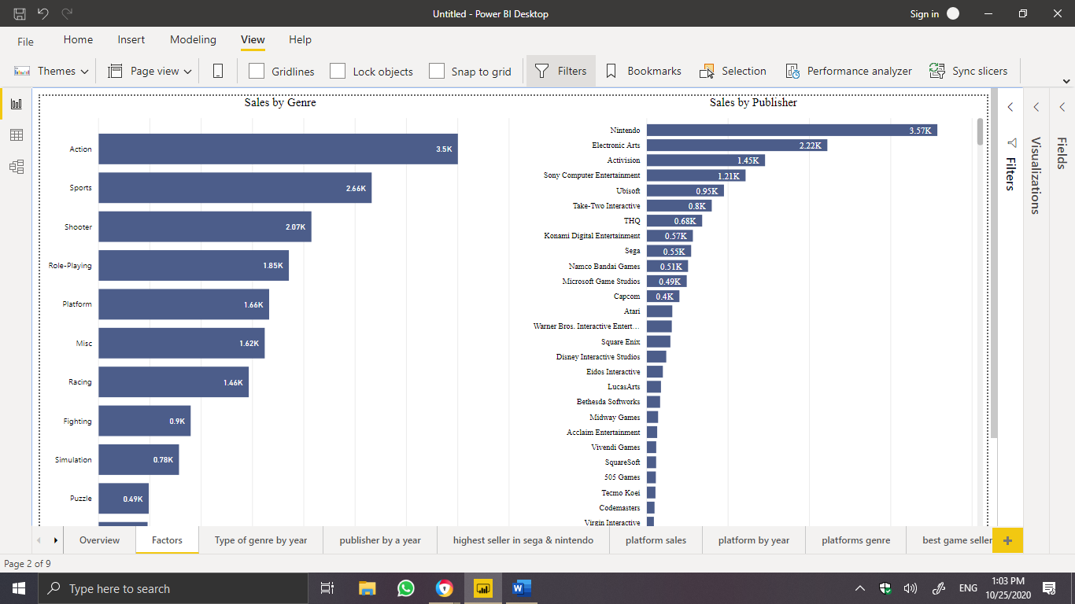

As you here the popular genre of games is **Action** , and the famous publisher is **Nintendo**

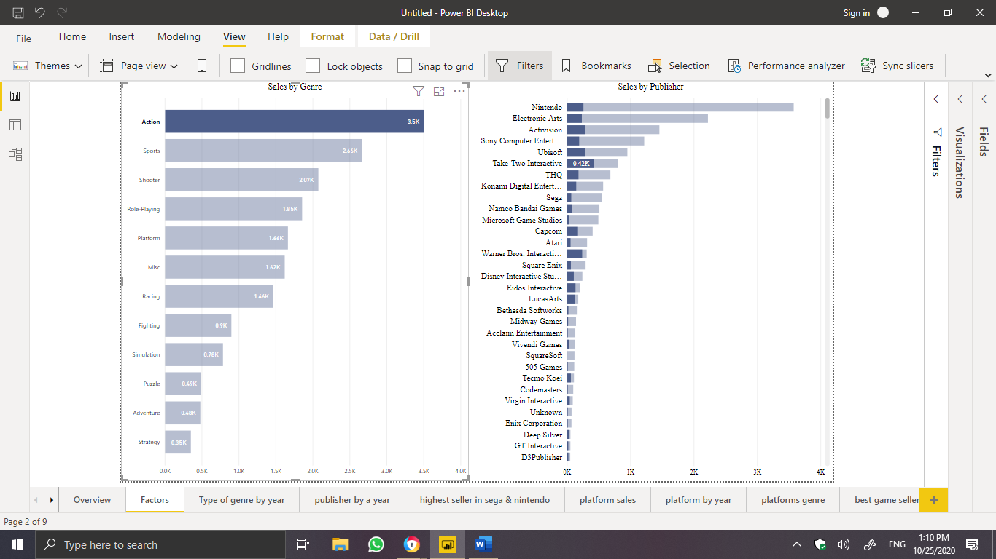

The **Take-tow-interactive** publisher is the highest sales by **Action** genre with **0.42K** .

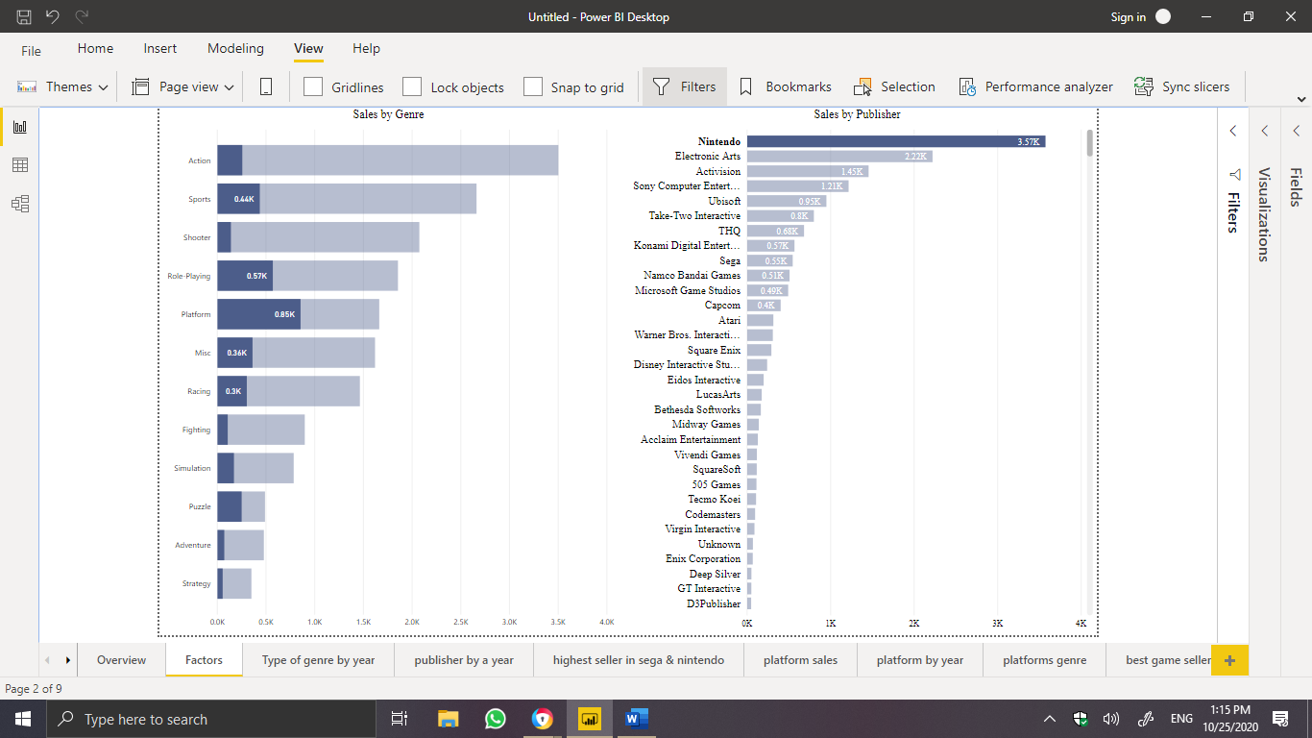

And the highest sales of **Nintendo** publisher is **platform** genre by **0.85K**.

These are 2 factors may affect the sales .

* Genre Sales :

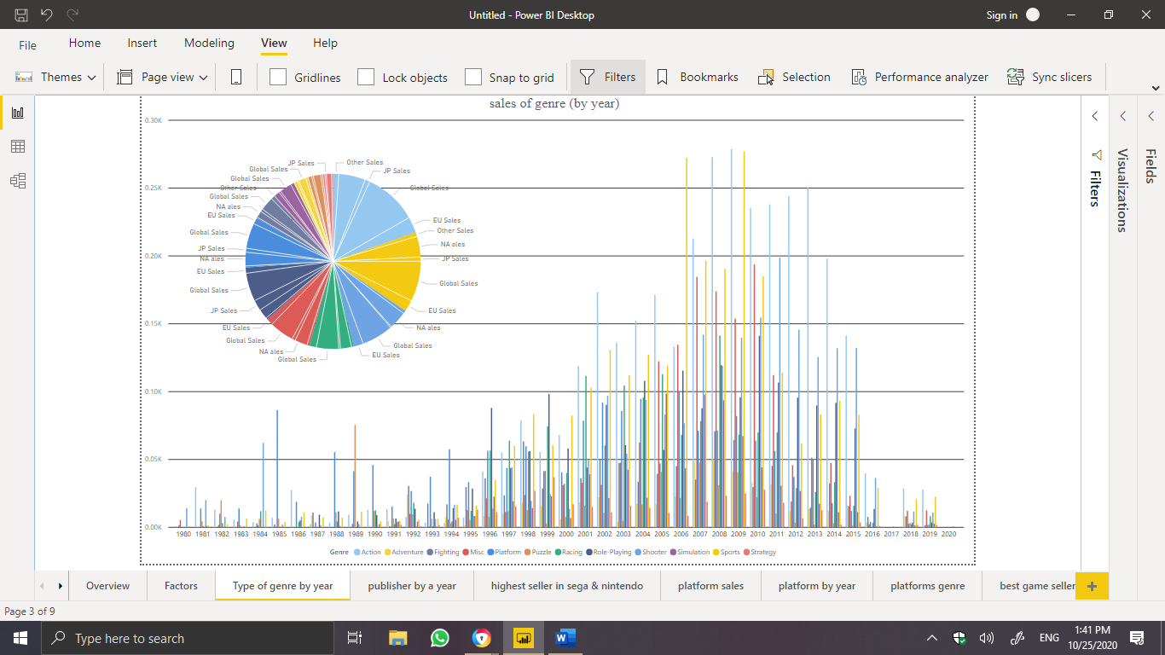

The figure above it show the sales of genre of game by the year, as it shows, the highest genre sales on 2008 is action highest with **272.80 $**, the highest genre on 2016 is Action with **39.76$**

the highest genre on 2017 Role-playing with **0.08$**, on 2018 the highest sale is Action with **28.70$** and 2019 with **27.90$** .

You may noticed that the sales of genre on 2009 higher than 2008 but the total sales in 2008 is highest and this is because the number of game in 2008 higher than 2009 .

* publisher sales :

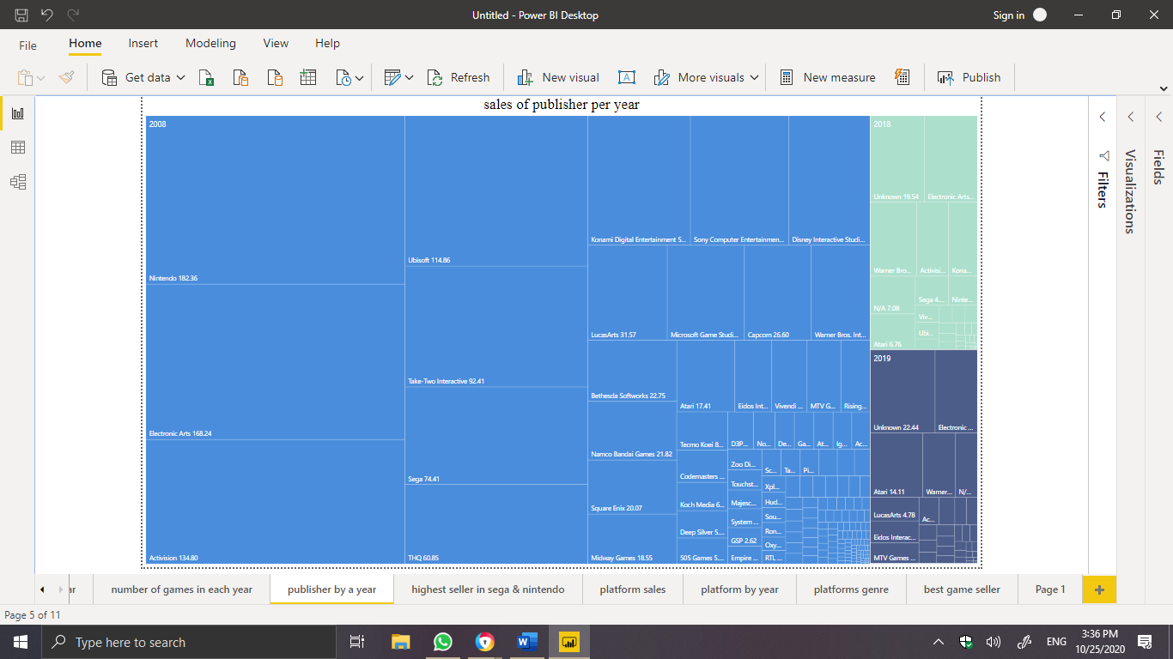

As you see here the highest publisher in 2008 is Nintendo with **182$** , on 2016 is Electronic Art with **24.52$** , on 2017 is Sega with **0.08$,** on 2018 is Unknown with **19.54$** and 2019 is Unknown too with **22.44$**.

Based on the publisher analysis the reason for decreasing the sales in 2017 might be because the publisher

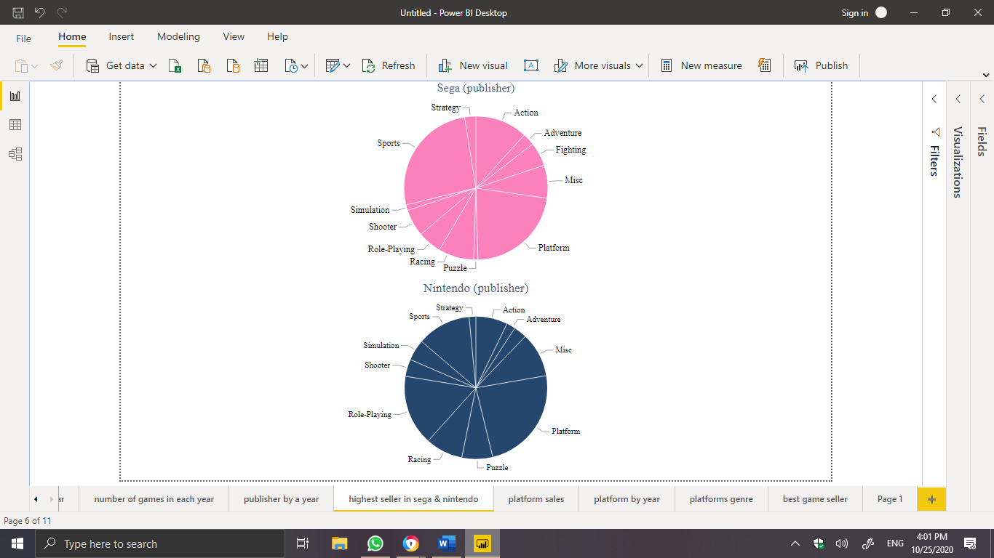

Sega , the sport genre has the highest sales with **143.39$** and in Nintendo the action genre has the highest sales with **854.39$ .**

Because in 2019 and 2018 the publisher is Unknown I used the platform to analysis it

to find the reason for the Increasing in the sales

* **platform** **sales** :

platform sales only in 2008 , 2016, 2017, 2018 and 2019 To find the change

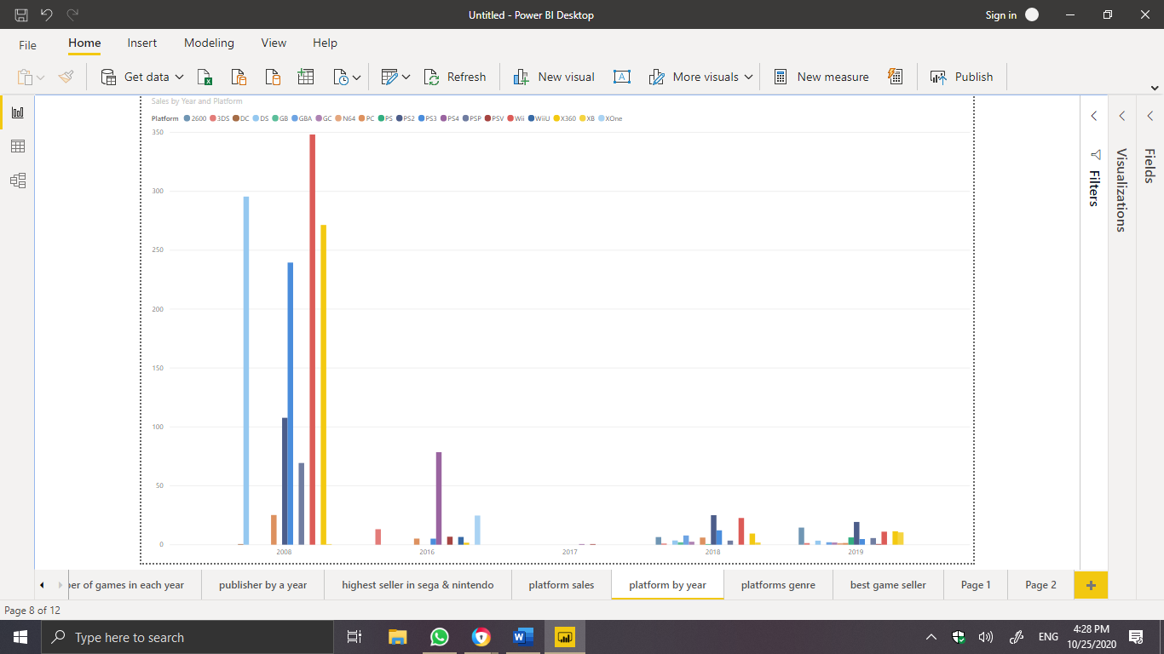

Based on the graph above , in 2008 wii has the highest sales with **348.24$** , in 2016 PS4 was the highest platform with **68.55$,** in 2017 is PS4 too with **0.06$** , in 2018 was the PS2 with **25.07$** , and in 2019 is PS2 with **19.32$** .

* **Platforms genre :**

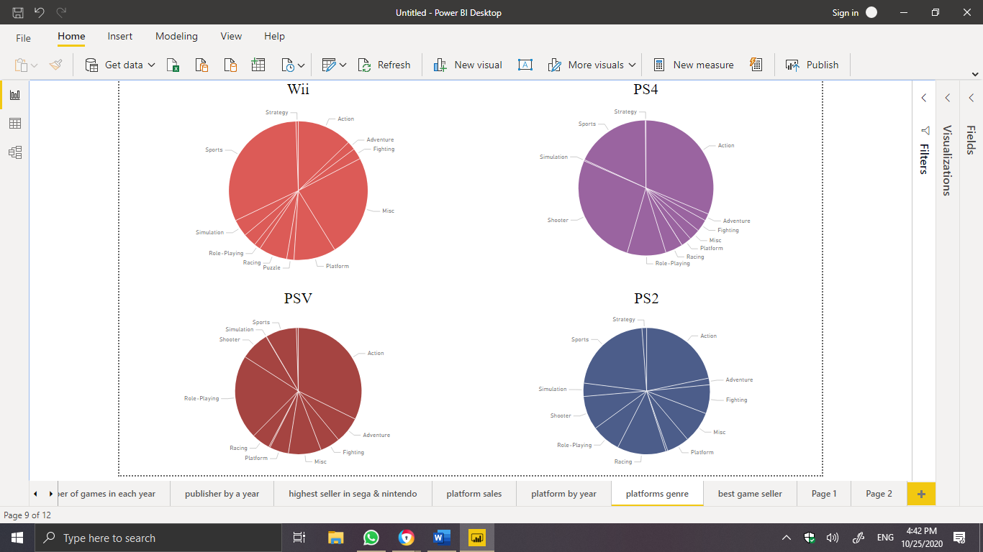

I found that, Wii has sport the highest sales , PS4 has Action the highest sales , PSV has Action the highest sales and PS2 has sport the highest sales .

**Conclusion**

I discover that , the reason for decreasing is the genre of game in 2017 which is was the Role-playing games , and as we see the popular genre games is action and 2017 doesn't have much of action games at all , So to Increase the sales is to create and develop more action games in the future , also it would be great if we cooperated with Nintendo publisher to create and developed these games because it has best sales in action games and PSV platform because it has the highest Action sales .

This is can improve the sales .